Panacea: A Novel Architecture for Electronic Health Records System using Blockchain and Machine Learning
Deep Rahul Shah ¹, Dev Ajay Dhawan¹, Pannag Rajesh Shah¹, Samit Nikesh Shah^{1,} and Sofia Francis¹
¹ NMIMS Mukesh Patel School of Technology Management and Engineering, Mumbai,
Maharashtra, India
{deepshah3110,devdhawan2689,shahpannag,samit2001.shah}@gmail.com,sofia.francis@nmims.edu
Abstract. In the information innovation unrest, electronic clinical records are a standard method for putting away patients' data in emergency clinics. Albeit some emergency clinic frameworks utilize server-based patient detail the board frameworks, they need a lot of capacity to store every one of the patients' clinical reports, in this manner influencing the versatility. Simultaneously, they are confronting a few troubles, for example, interoperability concerns, security and protection issues, digital assaults to the concentrated stockpiling, and keeping up with sticking to clinical approaches. The proposed model is a private blockchain-based patient detail the board framework as most would consider to be normal to resolve the above issues. Arrangement proposes an appropriate secure record to grants effective framework access and frameworks recovery, which is secure and unchanging and man-made consciousness fuelled instruments for clinical choice help. A better consensus system accomplishes the consensus of the information without huge energy use and organization congestion. Also, our model accomplishes high information security standards given a combination of crossbreed access control components, public-key cryptography, and a protected live ailment checking instrument. The proposed arrangement brings about effectively conveyed shrewd contracts according to the jobs of the framework, Ethereum based accreditation age and approval, Post Recovery Co-Morbidity Prediction, Disease Prediction Based on Symptoms and Drug Recommendation gave Side Effects. The general goal of this arrangement is to bring the whole clinical industry into a common stage utilizing a decentralized way to deal with a store, share clinical subtleties while disposing of the need to keep up with printed clinical records, and backing specialists utilizing exceptionally precise machine learning tools
Keywords: Blockchain, Machine Learning, Electronic Healthcare Records, Ethereum
- Introduction
Electronic medical services innovation is boundless worldwide and offers colossal potential for working on clinical outcomes and changing consideration conveyance. At the public level, EHR information is a decent sign of the general strength of the populace; at the institutional level, EHR information sharing can assist doctors with successfully surveying patients' conditions and making correct appraisals; and at the singular level, having complete EHR information, it is useful to work on the nature of EHR administration. As medical care advances, operability does as well, and communication between individual wellbeing areas rises. The digitalization of wellbeing and wellbeing data increments and breaks some clinical, business, and wellbeing data models. Numerous clinical establishments and medical clinics communicate through existing electronic wellbeing records (EHRs) to get perceptions, conclusions, and therapy data. Today, notice the ascent of huge information and IoT, the EHR and its worth increment dramatically. Despite advances in innovation, most wellbeing offices in certain countries depend on obsolete frameworks in different medical services regions. Electronic Health Record (EHR) contains incredible worth, yet in addition, infers a lot of individual protection.

Moreover, most wellbeing delicate information is put away and sent using concentrated designs. Because of its concentrated nature, interoperability across various wellbeing frameworks presents an extra test and a security issue. Because of the following security concerns and issues, another innovation called blockchain has arisen in the exploration fields of dispersed frameworks. Blockchain innovation has a pattern and expected reason in different fields of utilization. On account of its disseminated nature and information perpetual quality, Blockchain innovation endures likely disappointments and security weaknesses of incorporated frameworks. Notwithstanding security, Blockchain innovation gives an advanced method for confirming the proprietorship and validity of client information. Utilizing cryptographic strategies like PKI (Public key framework) additionally guarantees client obscurity and verification inside the shaky organization. Hence, the reception of blockchain can give promising answers for work with medical care conveyance and accordingly change the medical services industry. As an unavoidable utilization of organization innovation in the clinical field, Electronic Health Record (EHR) conveys a ton of individual data. In any case, current EHR Systems are not completely trusted by the patients because of the absence of straightforwardness about the information held and controlled by the wellbeing associations. Blockchain gives numerous framework characteristics that can contribute to lightening trust issues in medical services frameworks, for example, sealed information capacity and discernibility. There has been a lot of late work around the core thought of reception of blockchain and EHR information capacity frameworks.

Clinical analysis and therapy strategies are normally based on clinicians' translation of the patient's clinical information, which can frequently be abstract. It isn't uncommon for a patient to get various assessments from a few clinicians for an analyzed clinical issue. Utilizing man-made brainpower (AI) combined with blockchain innovation opens up new exploration open doors in the medical services area. Since machine and profound learning utilize a lot of information in their work, there is a valuable chance to foster better models by utilizing the decentralized idea of blockchains, which encourage straightforwardness, uprightness, and information sharing.

The Proposed engineering execution incorporates the capacity to cook consents the board, approval, and data dividing among the individuals. While getting information, access control execution assumes an urgent part. Henceforth, in this paper creators propose a crossover component that utilizes both Role-Based Access Controls (RBAC) and Attribute-Based Access Controls (ABAC) to give a more elevated level of safety. Besides, this examination project develops a component to screen a patient's live medical issue and to store it away through a solid channel. One more even-handed of this examination is to get patients' protection and give a quick and more adaptable system to access the information. It likewise has different highlights, for example, Ethereum controlled clinical certificate age and approval, post-recovery co-morbidities prediction, infection prediction based on manifestations, and drug recommendation with the most insignificant secondary effects.
- Related Work
With the ascent and prominence of distributed storage innovation, the common technique for EHR information sharing is that the information proprietor stores the scrambled EHR information on the cloud.

Patel et al. [1] proposed a blockchain-based system for cross-area clinical picture sharing and access control. The system would utilize the blockchain to make a disseminated record of radiological investigations and permit one more clinical foundation and patients to access the patient's radiological concentrate straightforwardly. The consent framework is based on open private cryptography, where every member in the organization is related to their public key and where every clinical establishment runs its hub on the organization. Along these lines, the organization would utilize its blockchain, with foundations going about as validators utilizing a PoS consensus. To safeguard patients’ security, the organization that made the review wouldn't distribute the picture information straightforwardly on the record.

Zhang et al. [2] proposed a task called" FHIRChain" to safely share EHR information utilizing the blockchain. The primary contrast to different methodologies is the spotlight that FHIRChain puts on being compliant with existing principles for EHR information sharing. The proposed approach is compatible with the HL7 FHIR interoperability standard .

Zyskind et al. [3] proposed an EHR information security assurance framework based on the outsider cell phone client, which collects and encodes information from the client's cell phone.

To work on the effectiveness of collection and capacity, Azaria et al. [4] proposed a decentralized climate to accomplish the administration of electronic EHR records.
On this premise, Xia et al. [5] combined distributed storage innovation to construct a sealed structure and understand the sharing of EHR information records.
To utilize the blockchain framework, Kevin Peterson et al. [6] understood the sharing of EHR information by utilizing blockchain innovation and proposed a clever consensus component.

Utilizing blockchain innovation, Ekbla et al. [7] proposed a conveyed data the executive’s framework to understand the validation, encryption, accountability, sharing, and lightweight appropriated stockpiling of delicate EHR data.

Fu et al. [8] based on crafted by Ekbla et al. [7] utilizing a superior encryption calculation to execute conveyed security and supplanting confirmation of work framework with a noteworthiness check component to work on the exhibition of medical care frameworks.

T.S. Raja Rajeswari et al. [9] proposed a decentralized web application that registers and approves the advanced education certificate on the Ethereum blockchain. When the information is placed by the client the subtleties of certificates are pushed on the Ethereum blockchain utilizing hashing. Utilizing this created hash they check the realness of the client.

Rakhmad Budiono et al.[10] proposed a COVID-19 test certificated administration utilizing blockchain. The framework was fabricated utilizing the Ethereum stage, which is a public non-permissioned blockchain that supports decentralized application improvement through brilliant contracts executed using EVM (Ethereum Virtual Machine). Their framework has been created utilizing a 3-layers design, which contains organization, programming, and application layer. The assessment showed that the framework effectively satisfies the COVID-19 test certificate the executive’s prerequisite. Their framework can be utilized for analyzer enrollment, and make, deny, show certificates.

Utilizing the Ethereum blockchain network, Irwan Afrianto et al. [11] proposed a Work Training Certificate Verification. The utilization of brilliant contracts is utilized to frame information that will be utilized in squares to be shipped off the Ethereum blockchain network. The InterPlanetary File System (IPFS) is utilized to store certificate documents in a dispersed climate so that access is simple and protected to do. The outcomes showed that certificate information can be put away in open blockchain Ethereum foundation and its supporting documents put away in the IPFS climate.

Hrithik Gaikwad et al. [12] proposed a web application that had a front-end for enrolling and mentioning checks, alongside a backend with two modules: An OCR module to remove subtleties from certificates and a Blockchain module to send and confirm information put away in the Blockchain. In this work, an endeavor has been made to foster an Ethereum based Blockchain-based check framework for scholarly certificates.

Haya Hasan et al.[13] carried out computerized clinical travel papers and invulnerability certificates for COVID-19 test-takers. They present brilliant contracts based on the Ethereum blockchain composed and tried effectively to keep a computerized clinical character for test-takers that assistance in a brief confided accordingly straight by the important clinical specialists. They diminish the reaction season of the clinical offices, reduce the spread of misleading data by utilizing unchanging trusted blockchain and control the spread of the illness through advanced clinical identifications.

Saikat Biswas et al.[14] propose a tensor factorization-based approach on natural information diagrams. Their strategy presents the concept of complex-esteemed implanting in information diagrams with organic elements. They construct an information diagram with sickness quality affiliations and their corresponding foundation data. To anticipate the relationship between pervasive sicknesses, they utilize a ComplEx inserting-based tensor decomposition strategy. Furthermore, we get new common sickness sets utilizing the Markov Cluster calculation in an illness quality organization and check their corresponding between relations utilizing edge prediction task.

BV Ramya et al. [15] anticipated new connections and missing connections between hubs in an informal community can be distinguished utilizing join prediction. They accomplished a precision of 96.28 utilizing Logistic Regression, 97.72% utilizing XGBoost, and 97.55% utilizing Bagging Classifier.

Md. Shafiur Rahman et al. [16] propose two connection prediction calculations: Local Link Prediction Algorithm and Global Link prediction by thinking about of client's exercises as well as the common companions.

But Kaya et al. [17] propose a clever connection prediction technique with a regulated procedure to recognize the connections between illnesses, fabricating the developing construction of the infection network for patients' ages. They probe a genuine organization exhibit that the proposed approach can uncover illness correlations precisely and perform well at catching future illness chances.

Liang et al. [18] anticipated connections and elements with an exactness of 93%, and its normal hits@10 score has a normal of 8.6% outright improvement compared with the first information inserting model, 1.1% to 9.7% outright improvement compared with another information and diagram implanting calculation.
- System Overview and Functionalities
Our model eventually centers around how to store patient wellbeing records safely, how to access, consume, and move the put-away information appropriately and solidly and propose choices for the simplicity of the specialists.

A private blockchain is utilized to accomplish this reason. It works in an emergency clinic-based climate where aside from a specialist, a patient, lab substances, clinical analysts, and medical care protection suppliers all play sub-roles according to given situations.

While giving a safe method for moving information among patients, specialists, and the medical clinic is the principal use of this proposed arrangement, the patient wellbeing checking system is presented as an imaginative and a worth-added component to our model.

Proposed blockchain electronic medical care records the executive’s framework utilizes social data set to store the metadata. According to the roles of the framework and honors of the chosen roles, brilliant contracts, AI devices, and access control strategies are executed while versatility is additionally addressed to guarantee the greatest effectiveness.

It is very difficult to assemble data and carry out a vigorous arrangement on the double with a quickly changing industry, for example, medical services. Subsequently, we have selected to utilize an iterative programming advancement approach to boost flexibility.

Functionalities of our proposed system are:

  - Smart Contracts
This study proposes a framework to further develop the current framework design of conventional printed structure-based records. There are various escape clauses in this customary methodology including the respectability of the records. To effectively oversee approval, this study proposes a brilliant contract to enroll and check the patient, other clinical help businesses, and the clinical records. Brilliant contracts are lines of code that are put away on a blockchain and consequently execute when foreordained agreements are met.In this proposed framework, Every medical clinic, protection element, research element are concerned as primary hubs.

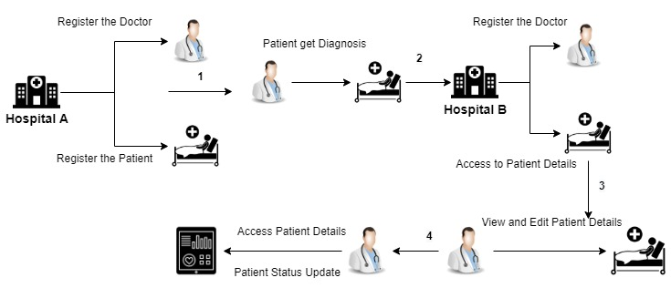
Fig. 1. Smart Contracts impact in Registration and Data Retrieval

The doctor and Patient come under the emergency clinic hub. Every hub goes about as an Ethereum client, moves information, and registers on the blockchain through the savvy contract. Because of the innate highlights of blockchain-based shrewd contracts unchanging nature is accomplished.

The above Figure reflects what the savvy contract means for the enrollment and information recovery process. In the absolute initial step, the doctor, and patient register through the enrollment work in the brilliant contract. When the framework confirms the enlistment status, consequently every one of the electronic clinical records will be transferred to the Interplanetary File framework (IPFS). Then, at that point, the hash esteem that IPFS produces from the clinical records is put away in the cloud space.

Assuming that enlisted doctor requirements to get the patient under his consultancy, he wants to consent to the brilliant contract. Assuming the patient visits an alternate enlisted doctor, the doctor can get to be aware of all clinical subtleties of the patient while tolerating the brilliant contract. On the off chance that he wants to make any update in the patient solution, again the shrewd contract will be set off.

Access control systems are ordinarily used to give security while accessing basic information assets, administrations, or extra room. The honors and privileges of subjects to access assets are characterized through access control approaches. According to the sort of information this arrangement is taking care of, it is basic to utilize legitimate access control systems to confirm partners. To accomplish this a Hybrid Access Control Mechanism has been utilized. Both Role-Based Access Controls (RBAC) and Attribute-Based Access Controls (ABAC) have been applied to give the necessary information access honors and privileges. The partners are patients and doctors, who are associating.

  - Blockchain Certificate System

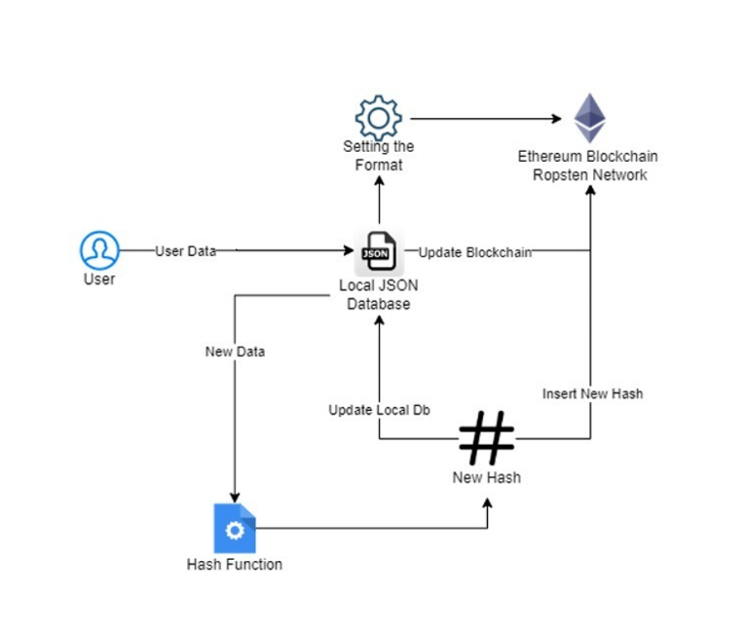

Fig. 2. Certificate System Architecture
Blockchain offers higher security, versatility, and adaptability Over customary Relational data sets.

A solid system showing in Figure 2 is proposed to approve and give clinical certificates on the blockchain. We take information from the client and push it onto an Ethereum test net called Ropsten. At the point when the exchange is effective on the blockchain remarkable hash esteem is put on the certificate The hash is created utilizing SHA-256 inside [19]. This hash worth can be utilized to demonstrate the credibility of the certificate. To check the subtleties we will give a pursuit page which consists of a hunt choice where the client can enter the exchange hash present on the certificate, On questioning utilizing Ropsten API, we will want to demonstrate whether the certificate is fashioned or substantial.

Conventional strategies are tedious and costly. As there is an association of a third individual in the check interaction it can prompt duplication of the certificate.[20].

In visual cryptography, An outsider individual is involved who gives a mystery picture with an id. We can't confide in a third individual every one of the time. The third individual can be handily controlled. The picture which we acquire from stacking every one of the mystery pictures has twisting which will impact the outcome.

Checking pictures and recognizing changes is based on AI. We realize that no AI model is 100 percent proficient. So it might create a few undesired outcomes some of the time. This activity is a costly cycle.

On the off chance that advanced mark isn't secure then, the archives can be fashioned. In this proposed framework there is no third individual included. Everything is straightforward. It brings about less cost and works rapidly. When the information is pushed to the blockchain the information becomes unchanging so nobody can transform it using any means. Utilizing the novel hash we can check the record. Blockchain is secure, adaptable, Scalable, and unchanging [21]

The age page takes three boundaries they show restraint Name, ID, and Meeting ID. When the doctor presses the create button the information will be pushed onto the brilliant contract. When the brilliant contract gets information from the age page it creates an interesting hash and the information is driven into the Ethereum blockchain. We are utilizing test ether[22] to perform exchange since unique ether costs 2.4lakh INR. Whenever the information is pushed the exchange log will be consequently driven into the Ropsten testnet [23].

The confirmation page takes one boundary for example exceptional hash. At the point when the doctor or the patient needs to approve the certificate, he sends an inquiry question alongside the produced hash address. The GET demand goes to Ropsten API and a JSON is returned. We process the JSON and will check regardless of whether the hash is available in the transaction log. Assuming found in the transaction log FOUND is returned else NOT FOUND is returned.
  - Post Recovery Co-Morbidity Prediction
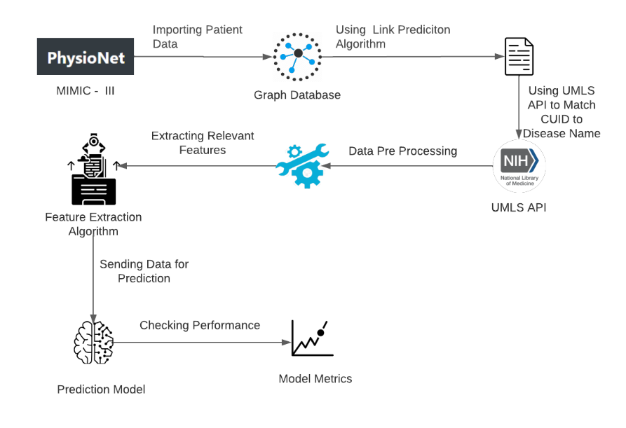
Fig. 3. Post-Recovery Comorbidity Prediction Workflow

Doctors can involve this tool for post-recovery prediction for comorbidity prediction is for doctors to break down the condition of the patients and other co-morbidities they might look after they have experienced a basic medical procedure.

The dataset utilized for prediction is MIMIC-III (Medical Information Mart for Intensive Care), an enormous, single-focus data set comprising data connecting with patients owned up to basic consideration units at a huge tertiary consideration clinic. The dataset consists of 112,000 clinical reports records (normal length 709.3 tokens) and 1,159 high-level ICD-9 codes. By and large. Model Dataset is produced utilizing topological connection prediction, hub embeddings, and hub order.

Involving Raw Data from MIMIC III in CSV design, we initially import it into the Graph Database. The information then, at that point, goes through Link Prediction Algorithm. Observing the match between the Patient and Notes hub, we make another hub that maps the connection among patients and their CUIDs (Concept Unique Identifiers). Utilizing UMLS (Unified Medical Language System) API, we then, at that point, convert all UUIDs to their infection name.

Utilizing this recently planned relationship we can observe the count of all extraordinary illnesses present in the information base.

Each distinct CUI (Concept Unique Identifier) code is connected to an ailment and the number of patents related to them who encountered those co-morbidities after going through a specific medical procedure or condition.

Each condition is correlated to the next in the type of twofold information to foresee their correlation.

  - Disease Prediction Based on Symptoms
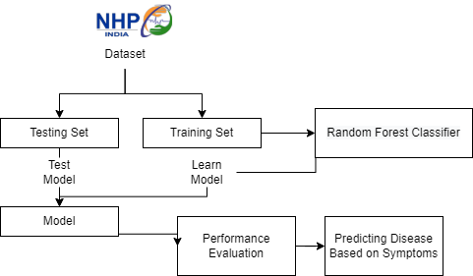

Fig. 4. Disease Prediction System workflow

Patients can enter a rundown of symptoms they are presently looking for before planning a meeting with the doctor on the gateway, to get more insights concerning their conditions and what different subtleties ought to be talked about with the doctor in the meet.

The Disease prediction system (shown in Figure 4) is constructed using the seven machine learning algorithms for instance Multinomial Naïve Bayes Classifier, Random Forest Classifier, Logistic Regression, K-Nearest Neighbors, Decision Tree, Support Vector Machines, and Multilayer Perceptron Classifier models.

The dataset used was from National Health Portal of India and contains 261 different diseases and more than 500 symptoms. The data is divided in 60:40 ratio into training and testing data. Parameters considered for predicting the disease were based upon list of symptoms entered by the users, the more the symptoms better the accuracy of disease. A solitary passage might contain a comparable distinguished sickness, for example, parasitic contamination however the indications in two sections for a similar infection are unique.

This informational index is then coordinated into one more informational collection by handling the crude passages. The new demonstrated informational collection contain manifestations as segment names and the columns indicate the recognized sickness. For each side effect happening for an illness, the segment passage is set apart as 1 for that manifestation while different sections are set apart as 0. Each algorithm is run to fir them on training data individually.

Then the accuracy of each model is calculated. Since the highest accuracy achieved was in Random Forest Classifier i.e., 91.06%, it is used in our system.
  - Drug Recommendation based on Side Effects

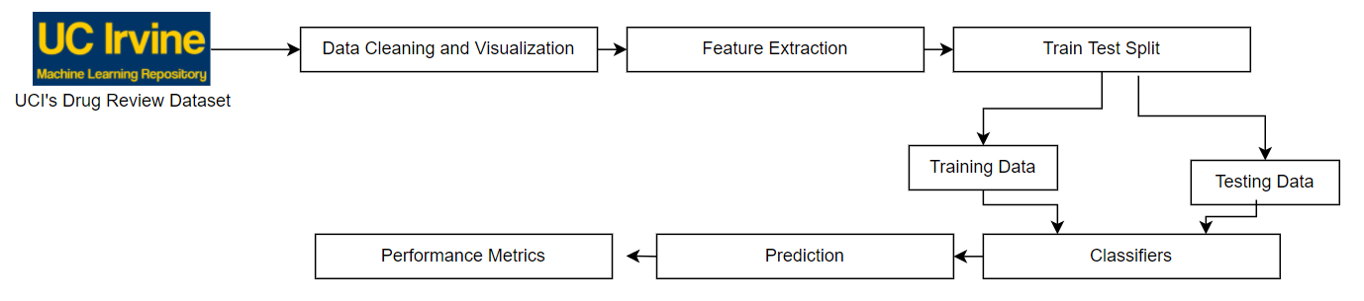
Fig. 5. Drug Recommendation System Workflow

This model (shown in Figure 5) can be involved by the patient to get recommendations for drugs based on their conceivable incidental effects and issues looked at by different patients who encountered them. No patient will be endorsed any given drug until it is being supported by the doctor's end, this apparatus is simply utilized for the client's very own insight purposes, and it wouldn't be coordinated towards individual use.

The dataset utilized was the University of California Irvine's Drug Review Dataset, which gives 215,063 patient drug surveys. The dataset is parted into the proportion of 75:25 in preparing and testing information.

Features are extricated utilizing Bag of Words, TF-IDF and Word2Vec Techniques. Classifiers carried out were Logistic Regression, Random Forest Classifier, AdaBoost Classifier, SDG Classifier, Support Vector Machines, and Multinomial Naïve Bayes Classifier.

Since the most elevated accuracy was accomplished in Logistic Regression i.e., 91.33% so it is utilized in our framework. On the off chance that the client picks a particular condition, drug subtleties and rundown will be given in plummeting requests from the most elevated mean standardized score to the most minimal, most elevated being the most recommended one with not very many secondary effects and most minimal being the least recommended one.

- Security and Privacy
In this section, we analyze the CIA security triad (Confidentiality, Integrity, and Availability) of the proposed system to show its capacity against several well-known attacks.We consider four attack scenarios that apply to a system of this type and analyze the resilience of the proposed architecture against each of them
Table 1. Security Scenarios
Attack | Effect in the current system | Risk level | Loss | Defense using Blockchain
Denial of Service | The aggressor sends a huge number of exchanges that can't be handled by the server to the fundamental capacity server, to crash the framework | Moderate | Availability | Because of collection, foothold flooding causes just a subset of bunches rather than each of the hubs in the organization.
Distributed Denial of  Service | This is an appropriate adaptation of the above assault. | Moderate | Availability | BlockChain can hypothetically allot information and data transmission to retain DDoS assaults as they occur
Modification Attack | Malignant or unapproved change on put away data | High | Integrity | Due to the usage of BlockChain immutable ledger and using hybrid access control mechanism
SQL injection | Utilizing SQL infusion instruments and code to take advantage of the data set tables | High | Confidentiality | BlockChain stores each data in separate  blocks and each block connected to the previous block

- Conclusion
In this paper creators, present a machine learning and a blockchain-based stage for the management of patient electronic records. Albeit a few changes are important to tweak the answer for production scale, key objectives and targets are accomplished. A further turn of events and upgrades can make the proposed arrangements a proficient and successful stage for both the community and the medical care industry. Even though all execution has effectively done according to the momentum client assumptions by utilizing the previously mentioned innovations and techniques, from the prerequisite social event to the consequences of the examination can be changed according to the future client necessities. Specialists will address the important prerequisites and will do the form administrations accordingly. Furthermore, blockchain and computerized reasoning fueled arrangement which is coordinated through a web application give an easy-to-understand road to draw in with the model administrations. It is additionally vital to take note that this large number of highlights are accomplished while regarding and sticking to administrative limitations, for example, HIPAA and GDPR making it appropriate for the business to take on without a second thought

References
- V. Patel, “A framework for secure and decentralized sharing of medical imaging data via blockchain consensus,” Health Informatics J, vol. 25, pp. 1398–1411, Dec. 2019.
- P. Zhang, J. White, D. C. Schmidt, G. Lenz, and S. T. Rosenbloom, “FHIRChain: Applying Blockchain to Securely and Scalably Share Clinical Data,” Computational and Structural Biotechnology Journal, vol. 16, pp. 267–278, Jan. 2018.
- G. Zyskind, O. Nathan, A. Pentland, “Decentralizing Privacy: Using Blockchain to Protect Personal Data,” IEEE Security and Privacy Workshops. IEEE Computer Society, 2015, pp. 180-184.
- A. Azaria, A. Ekblaw, T. Vieira, et al, “Med Rec: Using Blockchain for Medical Data Access and Permission Management,” International Conference on Open and Big Data. IEEE, 2016, pp. 25-30.
- Q. Xia, E. Sifah, A. Smahi, et al, “BBDS: Blockchain-Based Data Sharing for Electronic Medical Records in Cloud Environments,” Information, 2017, vol. 8, no. 2, pp. 44-44.
- K. Peterson, R. Deeduvanu, P. Kanjamala, et al. “A blockchain-based approach to health information exchange networks,” Proc. NIST Workshop Blockchain Healthcare, 2016, pp. 1-10.
- A. Ekblaw, A. Azaria, J. D. Halamka, et al, “A Case Study for Blockchain in Healthcare: “Med Rec” prototype for electronic health records and medical research data,” Proceedings of IEEE Open & Big Data Conference. 2016, pp. 13: 13.
- D. Fu, L. Fang, “Blockchain-based trusted computing in social network,” IEEE International Conference on Computer and Communications. IEEE, 2017, pp. 19-22.
- T. S. R. Rajeswari, S. K. Shareef, S. Khan, N. Venkatesh, A. Ali and V. S. Monika Devi, "Generating and Validating Certificates Using Blockchain," 2021 6th International Conference on Communication and Electronics Systems (ICCES), 2021, pp. 1048-1052, DOI: 10.1109/ICCES51350.2021.9489105.
- R. Budiono and M. C. Z. Candra, "Managing COVID-19 Test Certificates Using Blockchain Platform," 2021 International Conference on Data and Software Engineering (ICoDSE), 2021, pp. 1-5, DOI: 10.1109/ICoDSE53690.2021.9648482.
- I. Afrianto and Y. Heryanto, "Design and Implementation of Work Training Certificate Verification Based On Public Blockchain Platform," 2020 Fifth International Conference on Informatics and Computing (ICIC), 2020, pp. 1-8, DOI: 10.1109/ICIC50835.2020.9288610.
- H. Gaikwad, N. D’Souza, R. Gupta and A. K. Tripathy, "A Blockchain-Based Verification System for Academic Certificates," 2021 International Conference on System, Computation, Automation, and Networking (SCAN), 2021, pp. 1-6, DOI: 10.1109/ICSCAN53069.2021.9526377.
- H. R. Hasan et al., "Blockchain-Based Solution for COVID-19 Digital Medical Passports and Immunity Certificates," in IEEE Access, vol. 8, pp. 222093-222108, 2020, DOI: 10.1109/ACCESS.2020.3043350.
- Biswas S, Mitra P, Rao KS. Relation Prediction of Co-Morbid Diseases Using Knowledge Graph Completion. IEEE/ACM Trans Comput Biol Bioinform. 2021 Mar-Apr;18(2):708-717. DOI: 10.1109/TCBB.2019.2927310. Epub 2021 Apr 6. PMID: 31295118.
- B. Ramya, N. S. Varma, and R. Indra, "Recommendations in Social Network using Link Prediction Technique," 2020 International Conference on Smart Electronics and Communication (ICOSEC), 2020, pp. 782-786, DOI: 10.1109/ICOSEC49089.2020.9215236.
- M. S. Rahman, L. R. Dey, S. Haider, M. A. Uddin and M. Islam, "Link prediction by correlation on the social network," 2017 20th International Conference of Computer and Information Technology (ICCIT), 2017, pp. 1-6, DOI: 10.1109/ICCITECHN.2017.8281812.
- B. Kaya and M. Poyraz, "Finding relations between diseases by age-series based supervised link prediction," 2015 IEEE/ACM International Conference on Advances in Social Networks Analysis and Mining (ASONAM), 2015, pp. 1097-1103, DOI: 10.1145/2808797.2808812.
- Liang X, Li D, Song M, Madden A, Ding Y, Bu Y (2019) Predicting biomedical relationships using the knowledge and graph embedding cascade model. PLoS ONE 14(6): e0218264. https://doi.org/10.1371/journal.pone.0218264
- S. Gueron, S. Johnson and J. Walker, "SHA-512/256," 2011 Eighth International Conference on Information Technology: New Generations, 2011, pp. 354-358, DOI: 10.1109/ITNG.2011.69
- T. Kanan, A. T. Obaidat and M. Al-Lahham, "Smart Cert BlockChain Imperative for Educational Certificates, "2019 IEEE Jordan International Joint Conference on Electrical Engineering and Information Technology (JEEIT), Amman, Jordan, 2019, pp. 629-633, DOI: 10.1109/JEEIT.2019.8717505
- A. A. Monrat, O. Schelén, and K. Andersson, "A Survey of Blockchain From the Perspectives of Applications, Challenges, and Opportunities," in IEEE Access, vol. 7, pp. 117134-117151, 2019, DOI: 10.1109/ACCESS.2019.2936094
- K. Pushpa Rani, T.S.Raja Rajeswari, N. Thulasi Chitra “Applying Sentiment Analysis Techniques To Measure The Performance Of Engineering Educators To Improve Academic Standards” International Journal of Grid and Distributed Computing Vol. 13, No. 2, (2020), pp. 1564-1569
- T.S.RajaRajeswari, N.Thulasi Chitra ,S.Spandana “Security Improvement Malware Detection Using Impact of PCA Function Extraction”, International Journal of Grid and Distributed Computing Vol. 13, No. 2, (2020), pp. 1577-1584

